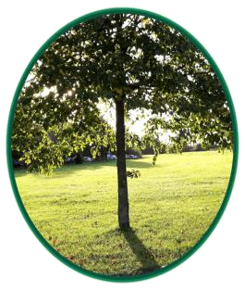
HALEBANK PARISH COUNCIL
TERMS OF REFERENCE FOR
THE PLANNING COMMITTEE

These rules are supplemental to, and do not in any way override, the Parish Council’s Standing Orders &/or Financial Regulations.

Membership of the Planning Committee
The Committee shall be elected, and may be re-elected, at the Annual Meeting of the Parish Council and will consist of all members of the Parish Council. The quorum of the Committee shall be three.

Procedures

- At the first meeting of the Committee after the Annual Meeting of the Parish Council, the Committee shall elect a Chair and if the Committee deems necessary a Vice Chair for the forthcoming year from amongst the Committee membership.
- The Committee shall submit its minutes for adoption to the next meeting of the Parish Council.
- The Clerk shall provide administrative support for the Committee.

Committee Functions

- To respond on behalf of the Council to requests from the local planning auithority in any planning applications, tree preservation orders and breaches of planning control.
- Where appropriate, prepare for the Council, grounds for supporting the local planning authority in any planning appeals against refusal of planning permission.
- To advise the Parish Council on any planning matters.
- To respond on behalf of the Parish Council to applications for grant and/or transfer of personal and Premises Licences and Gaming Permits.
- To respond on behalf of the Council to consultation documents from any appropriate Government body and other local Councils.

Delegated Powers

- To determine and submit the Councils observations on planning application.
- To undertake such actions, publicity and consultations considered necessary to provide residents with an opportunity to make representations on planning applications and other planning matters.
- To appoint working groups to research and advise the Committee on planning applications and appeals.
- To determine and submit the Council’s comments on applications for the grant and/or transfer of Personal and Premises Licences and Gaming Permits.
- To determine and submit the Council’s comments on consultation documents from any appropriate Government body and other Councils.
- To Liaise with planning consultants and Legal bodies in respect of Planning applications and if necessary (due to time constraints) advise and instruct.

