

Halebank Parish Council

ALWAYS PUTTING THE PEOPLE OF HALEBANK
FIRST

REVIEWED MAY 2024

Member Code of Conduct

- Background to this Code of Conduct

  - This section sets out general interpretation and background to the Code of Conduct, including definitions used within the code, the purpose of the code, the principles the code is based on and when the code applies. It does not form part of the Code of Conduct itself and consequently does not contain any obligations for you to follow, as these are contained in the ‘Code of Conduct’ section below.

  - All councils are required to have a local Member Code of Conduct.

Definitions

  - For the purposes of this Code of Conduct, a “member” means a member or co-opted member of Halebank Parish Council (“the Council”).

  - A “co-opted member” is defined in the Localism Act 2011 Section 27(4) as “a person who is not a member of the authority but who

    - is a member of any committee or sub-committee of the authority, or;
    - is a member of, and represents the authority on, any joint committee or joint subcommittee of the authority.

and who is entitled to vote on any question that falls to be decided at any meeting of
that committee or sub-committee”.

Purpose of the Code of Conduct

  - The purpose of this Code of Conduct is to assist you, as a member, in modelling the behaviour that is expected of you, to provide a personal check and balance, and to set out the type of conduct that could lead to action being taken against you. It is also to protect you, the public, fellow members, Council officers and the reputation of the Council and local government. It sets out general principles of conduct expected of all members and your specific obligations in relation to standards of conduct. The fundamental aim of the Code is to create and maintain public confidence in the role of member and local government.

General principles of member conduct

  - Everyone in public office at all levels; i.e. all who serve the public or deliver public services, including ministers, civil servants, members and council officers; should uphold the Seven Principles of Public Life, also known as the Nolan Principles, which are set out in Appendix A.

  - Building on these principles, the following general principles have been developed specifically for the role of member and these principles underpin the obligations in the Code of Conduct that follows.

  - In accordance with the public trust placed in you,

you should:

    - act with integrity and honesty
    - act lawfully
    - treat all persons fairly and with respect;
    - lead by example and act in a way that secures public confidence in the role of member.

  - In undertaking your role, you should:

    - impartially exercise your responsibilities in the interests of the local community
    - do not improperly seek to confer an advantage, or disadvantage, on any person
    - avoid conflicts of interest
    - exercise reasonable care and diligence.
    - ensure that public resources are used prudently in accordance with your Council’s requirements and in the public interest;
    - uphold high standards of conduct, show leadership at all times and not misuse your position when acting as a member.

Application of the Code of Conduct

  - This Code of Conduct applies to you as a member or co-opted member of the Council. It applies as soon as you sign your declaration of acceptance of the office of member or attend your first meeting as a co-opted member and continues to apply to you until you cease to be a member.

  - This Code of Conduct applies to you when you:

    - act in your capacity as a member or co-opted member of the Council;
    - conduct the business of the Council (which, in this Code, includes the business of the office to which you are elected or appointed).

  - Where you act as a representative of the Council:

    - on another relevant authority, you must, when acting for that other authority, comply with that other authority’s code of conduct; or
    - on any other body, you must, when acting for that other body, comply with this Code of Conduct, except and insofar as it conflicts with any other lawful obligations to which that other body may be subject.

  - The Code applies to all forms of communication and interaction, including:

    - at face-to-face meetings
    - at online or telephone meetings
    - in written communication
    - in verbal communication
    - in non-verbal communication
    - in electronic and social media communication, posts, statements, and comments.

  - Your Monitoring Officer has statutory responsibility for the implementation of the Code of Conduct. It is your responsibility to comply with the provisions of this Code and to ensure all its obligations are met. You are encouraged to seek advice from the Monitoring Officer on any matters that may relate to the Code of Conduct which you are unsure of. Town and parish members are encouraged to seek advice from their Monitoring Officer or Clerk (who may refer matters to the Monitoring Officer.

- THE CODE OF CONDUCT

Standards of member conduct

  - This section sets out your obligations, which are the minimum standards of conduct required of you as a member. Should your conduct be perceived to fall short of these standards or the Nolan Principles, a complaint may be made against you, which may result in action being taken.

  - Guidance is included to help explain the reasons for the obligations and how they should be followed.

General Conduct

Respect

2.3 As a member:

2.3.1 I will treat others with respect.

2.3.2 I will treat council officers, employees and representatives of partner organisations and those volunteering for the council with respect and respect the role they play.

2.4 Respect means politeness and courtesy in behaviour, speech, and in the written word. Debate and having different views are all part of a healthy democracy. As a member, you can express, challenge, criticise and disagree with views, ideas, opinions and policies in a robust but civil manner. You should not, however, subject individuals, groups of people or organisations to personal attack.

2.5 In your contact with the public, you should treat them politely and courteously. Rude and offensive behaviour lowers the public’s expectations and confidence in members.

2.6 In return, you have a right to expect respectful behaviour from the public. If members of the public are being abusive, intimidatory or threatening you are entitled to stop any conversation or interaction in person or online and notify them to the Council, the relevant social media provider or the police. This also applies to fellow members, where action could then be taken under the Member Code of Conduct, and council officers where concerns should be raised in line with the council’s member-officer protocol.

Bullying, harassment, and discrimination

2.7 As a member:

2.7.1 I will not bully any person.

2.7.2 I will not harass any person.

2.7.3 I will promote equalities and do not discriminate unlawfully against any person.

2.8 The Advisory, Conciliation and Arbitration Service (ACAS) characterises bullying as offensive, intimidating, malicious or insulting behaviour, an abuse or misuse of power through means that undermine, humiliate, denigrate or injure the recipient. Bullying might be a regular pattern of behaviour or a one-off incident, happen face-to-face, on social media, in emails or phone calls, happen in the workplace or at work social events and may not always be obvious or noticed by others.

2.9 The Protection from Harassment Act 1997 defines harassment as conduct that causes alarm or distress or puts people in fear of violence and must involve such conduct on at least two occasions. It can include repeated attempts to impose unwanted communications and contact upon a person in a manner that could be expected to cause distress or fear in any reasonable person.

2.10 Unlawful discrimination is where someone is treated unfairly because of a protected characteristic. Protected characteristics are specific aspects of a person's identity defined by the Equality Act 2010. They are age, disability, gender reassignment, marriage and civil partnership, pregnancy and maternity, race, religion or belief, sex and sexual orientation.

2.11 The Equality Act 2010 places specific duties on local authorities. Members have a central role to play in ensuring that equality issues are integral to the Council's performance and strategic aims, and that there is a strong vision and public commitment to equality across public services.

Impartiality of officers of the Council

2.12 As a member I will not compromise, or attempt to compromise, the impartiality of anyone who works for, or on behalf of, the council.

2.13 Officers work for the council as a whole and must be politically neutral (unless they are political assistants). They should not be coerced or persuaded to act in a way that would undermine their neutrality. You can question officers in order to understand, for example, their reasons for proposing to act in a particular way, or the content of a report that they have written. However, you must not try and force them to act differently, change their advice, or alter the content of that report, if doing so would prejudice their professional integrity.

Confidentiality and access to information

2.14 As a member:

2.14.1 I will not disclose information:

- given to me in confidence by anyone
- acquired by me which I believe,or ought reasonably to be aware, is of a confidential nature, unless:
,
i. I have received the consent of a person authorised to give it; ii. I am required by law to do so. iii. the disclosure is made to a third party for the purpose of obtaining professional legal advice provided that the third party agrees not to disclose the information to any other person; or
iv. the disclosure is:

1. reasonable and in the public interest; and
- made in good faith and in compliance with the reasonable requirements of the Council; and
- I have consulted the Clerk prior to its release.

2.14.2 I will not improperly use knowledge gained solely as a result of my role as a member for the advancement of myself, my friends, my family members, my employer, or my business interests.

2.14.3 I will not prevent anyone from getting information that they are entitled to by law.

2.15 Local authorities must work openly and transparently, and their proceedings and printed materials are open to the public, except in certain legally defined circumstances. You should work on this basis, but there will be times when it is required by law that discussions, documents and other information relating to or held by the council must be treated in a confidential manner. Examples include personal data relating to individuals or information relating to ongoing negotiations.

Disrepute

2.16 As a member I will not bring my role or Council into disrepute or conduct myself in a manner which could reasonably be regarded as bringing my role or Council into disrepute.

2.17 As a Member, you are trusted to make decisions on behalf of your community and your actions and behaviour are subject to greater scrutiny than that of ordinary members of the public. You should be aware that your actions might have an adverse impact on you, other members and/or the Council and may lower the public’s confidence in your or the Council’s ability to discharge your/its functions. For example, behaviour that is considered dishonest and/or deceitful can bring the Council into disrepute.

2.18 You are able to hold the Council and fellow members to account and are able to constructively challenge and express concern about decisions and processes undertaken by the Council whilst continuing to adhere to other aspects of this Code of Conduct.

Use of position

2.19 As a member:

2.19.1 I will not use, or attempt to use, my position improperly to the advantage or disadvantage of myself or anyone else.
2.19.2 I will not place myself under a financial or any other obligation to outside individuals or organisations that might seek to influence me in the performance of my official duties.

2.20 Your position as a member of the Council provides you with certain opportunities, responsibilities, and privileges, and you make choices all the time that will impact others. However, you should not take advantage of these opportunities to further your own or others’ private interests or to disadvantage anyone unfairly.

2.21 As a member you need to be able to act impartially in the exercise of your responsibilities and ensure that you make decisions in the interests of the local community. You should therefore avoid any financial or other obligations to outside individuals or organisations whose influence may prevent you from acting impartially.

Use of Council resources and facilities

2.22 As a member:

2.22.1 I will not misuse council resources.

2.22.2 I will, when using the resources of the Council or authorising their use by others:

- act in accordance with the Council's requirements; and
- ensure that such resources are not used for political purposes unless that use could reasonably be regarded as likely to facilitate, or be conducive to, the discharge of the functions of the Council or of the office to which I have been elected or appointed.

2.23 You may be provided with resources and facilities by the Council to assist you in carrying out your duties as a member. Examples include:
- office support
- stationery
- equipment such as phones, iPad, dongles, computers etc.
- transport
- access and use of council buildings and rooms.

2.23 These are given to you to help you carry out your role as a member more effectively and are not to be used for business or personal gain. They should be used in accordance with the purpose for which they have been provided and the council’s own policies regarding their use.

Making decisions

2.24 As a member:

2.24.1 When reaching decisions on any matter I will have regard to any relevant advice provided to me by officers and professional third parties.

2.24.2 I will give reasons for all decisions in accordance with any statutory requirements and any reasonable additional requirements imposed.

2.24.3 I will make all choices, such as making public appointments, awarding contracts, or recommending individuals for rewards or benefits, on individual and independent merit.

2.24.4 I will be as open as possible about my decisions and actions and the decisions and actions of the authority and will be prepared to give reasons for those decisions and actions, notwithstanding my other obligations under this Code.

2.25 To assist members in acting lawfully, officers may give advice from time to time. It is important that as a member you have due regard to any such advice given and consider it fully, even if (for good reason) you may choose not to follow that advice.

2.26 In making any decisions, giving reasons helps instil public confidence in the role of the member and can be a legal requirement in certain situations. You should ensure that you always give reasons in accordance with any specific requirements and having regard to the benefits of transparency generally.

2.27 As a member you must act impartially and not improperly seek to confer an advantage, or disadvantage, on any person. It is therefore important that when you are making decisions that involve choosing one party over another, that you do so based on independent merit. You should be open and transparent about the decisions that you have made and the actions of the authority.

Complying with the Code of Conduct

2.28 As a member:

2.28.1 I will undertake Code of Conduct training provided by my Council.

2.28.2 I will cooperate with any Code of Conduct investigation and/or determination.

2.28.3 I will not intimidate or attempt to intimidate any person who is likely to be involved with the administration of any investigation or proceedings.

2.28.4 I will comply with any sanction imposed on me following a finding that I have breached the Code of Conduct.

2.29 It is extremely important for you as a member to demonstrate high standards, for you to have your actions open to scrutiny and for you not to undermine public trust in the Council or its governance. If you do not understand or are concerned about the council’s processes in handling a complaint you should raise this with the Monitoring Officer.

Protecting your reputation and the reputation of the Council

Interests

2.30 As a member I will register and disclose my interests in accordance with the provisions set out in Appendix B

2.31 Section 29 of the Localism Act 2011 requires the Monitoring Officer to establish and maintain a register of interests of members of the authority.

2.32 You need to register your interests so that the public, Council employees and fellow members know which of your interests might give rise to a conflict of interest. The register is a public document that can be consulted when (or before) an issue arises. The register also protects you by allowing you to demonstrate openness and a willingness to be held accountable. You are personally responsible for deciding whether or not you should disclose an interest in a meeting, but it can be helpful for you to know early on if others think that a potential conflict might arise. It is also important that the public know about any interest that might have to be disclosed by you or other members when making or taking part in decisions, so that decision making is seen by the public as open and honest. This helps to ensure that public confidence in the integrity of local governance is maintained.

2.33 You should note that failure to register or disclose a disclosable pecuniary interest as defined in Appendix B, is a criminal offence under the Localism Act 2011.

2.34 The provisions of this paragraph 10.1 shall be applied in such a manner as to recognise that this Code of Conduct should not obstruct a member’s service on more than one local authority. For the avoidance of doubt, participation in discussion and decision-making at one local authority will not by itself normally prevent you from taking part in discussion and decision-making on the same matter at another local authority. This is on the basis that a reasonable member of the public will see no objection in principle to such service or regard it as prejudicing a member’s judgement of the public interest and will only regard a matter as giving rise to an interest which might lead to bias in exceptional circumstances.

2.35 Appendix B sets out the detailed provisions on registering and disclosing interests. If in doubt, you should always seek advice from the Monitoring Officer, or from the clerk in the case of town and parish councils.

Gifts and hospitality

2.36 As a member:

2.36.1 I will not accept gifts or hospitality, irrespective of estimated value, which could give rise to real or substantive personal gain or a reasonable suspicion of influence on my part to show favour from persons seeking to acquire, develop or do business with the Council or from persons who may apply to the Council for any permission, licence or other significant advantage.

2.36.2 I will register with the Clerk any gift or hospitality with an estimated value of at least £50 within 28 days of its receipt.

2.36.3 I will register with the Clerk any significant gift or hospitality with an estimated value of at least £50 that I have been offered but have refused to accept.

2.37 In order to protect your position and the reputation of the Council, you should exercise caution in accepting any gifts or hospitality which are (or which you reasonably believe to be) offered to you because you are a member. The presumption should always be not to accept significant gifts or hospitality. However, there may be times when such a refusal may be difficult if it is seen as rudeness in which case you could accept it but must ensure it is publicly registered. However, you do not need to register gifts and hospitality which are not related to your role as a member, such as Christmas gifts from your friends and family. It is also important to note that it is appropriate to accept normal expenses and hospitality associated with your duties as a member. If you are unsure, do contact the Monitoring Officer or clerk for guidance.

Dispensations

2.38 As a member:

2.38.1 I may request a dispensation from the Clerk/RFO for a particular meeting.

2.38.2 I must make the request in writing detailing what my interest is, why the dispensation is required and for what meeting.

2.38.3 I must make my request 5 days prior to the meeting at which the Dispensation is required.

| Page
2.38.4 If I wish to make a further request for dispensation, this must be made to the Clerk/RFO.

2.38.5 I will only be granted a Dispensation where there are reasonable grounds for doing so and where such grounds are in the public interest.

2.39 Appendix B sets out the situations where a member’s personal interest in a matter may prevent them from participating in the decision-making process. In certain circumstances, however, there may be reasonable grounds to allow a member to participate in decision-making on that matter where it would be in the public interest to do so. Where you consider that there may be good grounds for you to continue to participate you should request a dispensation from the Monitoring Officer or

| Page
Appendix A

The Seven Principles of Public Life

The principles are:

Selflessness

Holders of public office should act solely in terms of the public interest.

Integrity

Holders of public office must avoid placing themselves under any obligation to people or organisations that might try inappropriately to influence them in their work. They should not act or take decisions in order to gain financial or other material benefits for themselves, their family, or their friends. They must disclose and resolve any interests and relationships.

Objectivity

Holders of public office must act and take decisions impartially, fairly and on merit, using the best evidence and without discrimination or bias.

Accountability

Holders of public office are accountable to the public for their decisions and actions and must submit themselves to the scrutiny necessary to ensure this.

Openness

Holders of public office should act and take decisions in an open and transparent manner. Information should not be withheld from the public unless there are clear and lawful reasons for so doing.

Honesty

Holders of public office should be truthful.

Leadership

Holders of public office should exhibit these principles in their own behaviour. They should actively promote and robustly support the principles and be willing to challenge poor behaviour wherever it occurs.

Appendix B

Interests

1. Definitions

“Disclosable Pecuniary Interest” means any interest described as such in the Relevant Authorities (Disclosable Pecuniary Interests) Regulations 2012 and includes an interest of yourself, or of your Partner (if you are aware of your Partner's interest) that falls within the descriptions set out in the following table. A Disclosable Pecuniary Interest is a Registerable Interest.

Subject | Description
Employment, office, trade, profession, or vocation | Any employment, office, trade, profession, or vocation executed for profit or gain.  Any unpaid directorship.
Sponsorship | Any payment or provision of any other financial benefit (other than from the council) made to the member during the previous 12-month period for expenses incurred by him/her in carrying out his/her duties as a member, or towards his/her election expenses.  This includes any payment or financial benefit from a trade union within the meaning of the Trade Union and Labour Relations (Consolidation) Act 1992.
Contracts | Any contract made between the member or his/her spouse or civil partner or the person with whom the member is living as if they were spouses/civil partners (or a firm in which such person is a partner, or an incorporated body of which such person is a director* or a body that such person has a beneficial interest in the securities of*) and the council  - under which goods or services are to be provided or works are to be executed; and  - which has not been fully discharged.
Land and Property | Any beneficial interest in land which is within the area of the council. ‘Land’ excludes an easement, servitude, interest or right in or over land which does not give the member
 | or his/her spouse or civil partner or the person with whom the member is living as if they were spouses/ civil partners (alone or jointly with another) a right to occupy or to receive income.
Licenses | Any licence (alone or jointly with others) to occupy land in the area of the council for a month or longer.
Corporate tenancies | Any tenancy where (to the member’s knowledge)  - the property owner is the council; and  - the tenant is a body that the member, or his/her spouse or civil partner or the person with whom the member is living as if they were spouses/ civil partners is a partner of or a director* of or has a beneficial interest in the securities* of.
Securities | Any beneficial interest in securities* of  a body where—  - that body (to the member’s knowledge) has a place of business or land in the area of the council; and  - either—  - the total nominal value of the securities* exceeds £25,000 or one hundredth of the total issued share capital of that body; or  - if the share capital of that body is of more than one class, the total nominal value of the shares of any one class in which the member, or his/ her  spouse or civil partner or the  person with whom the member  is living as if they were spouses/civil partners has a beneficial interest exceeds one hundredth of the total issued share capital of that class.

  - “director” includes a member of the committee of management of an industrial and provident society.
  - “securities” means shares, debentures, debenture stock, loan stock, bonds, units of a collective investment scheme within the meaning of the Financial Services and Markets Act 2000 and other securities of any description, other than money deposited with a building society.

"Partner" means a spouse or civil partner, or a person with whom you are living as husband or wife, or a person with whom you are living as if you are civil partners.

“Other Registerable Interest” is a personal interest in any business of your authority which relates to or is likely to affect:

- any body of which you are in general control or management and to which you are nominated or appointed by your authority; or

- any body
  - exercising functions of a public nature;
  - any body directed to charitable purposes; or
  - one of whose principal purposes includes the influence of public opinion or policy (including any political party or trade union)

“Registrable Interests” are interests that you are required to register in accordance with this Code of Conduct and include both Disclosable Pecuniary Interests and Other Registerable Interests.

“Non-Registrable Interests” are interests that you are not required to register but need to be disclosed in accordance with section 3.3.

A “Dispensation” is agreement that you may continue to participate in the decisionmaking process notwithstanding your interest as detailed at section 12 of the Code of the Conduct and this Appendix B.

A “Sensitive Interest” is as an interest which, if disclosed, could lead to the member, or a person connected with the member, being subject to violence or intimidation. In any case where this Code of Conduct requires to you to disclose an interest (subject to the agreement of the Monitoring Officer in accordance with paragraph 2.2 of this Appendix regarding registration of interests), you do not have to disclose the nature of the interest, if it is a Sensitive Interest. In such circumstances you just have to disclose that you have an interest.

A matter “directly relates” to one of your interests where the matter is directly about that interest. For example the matter being discussed is an application about a particular property in which you or somebody associated with you has a financial interest.

A matter “affects” your interest where the matter is not directly about that interest but would still have clear implications for the interest. For example, the matter concerns a neighbouring property.

- Registering Interests

  - Within 28 days of becoming a member or co-opted member or your re-election or re-appointment to office you must register with the Monitoring Officer any Disclosable Pecuniary Interests and any Other Registerable Interests.

  - Where you have a Sensitive Interest you must notify the Monitoring Officer with the reasons why you believe it is a Sensitive Interest. If the Monitoring Officer agrees they will withhold the interest from the public register.

  - You must ensure that your register of interests is kept up-to-date and within 28 days of becoming aware of any new interest, or of any change to a registered interest, notify the Monitoring Officer.

- Declaration at and Participation in Meetings

If you are present at a meeting and you have either a Registerable or NonRegisterable Interest in any matter to be considered or being considered, and the interest is not a Sensitive Interest, you must disclose that interest to the meeting (whether or not it is registered).

To determine whether your interest affects your ability to participate in a meeting, you must first determine what type of interest you have and, if necessary, go on to apply the tests as set out below.

3.1 Disclosable Pecuniary Interests

3.1.1 Where a matter arises at a meeting which directly relates to one of your Disclosable Pecuniary Interests subject to paragraph 3.2.2 below:

- you must disclose the interest.
- not participate in any discussion or vote on the matter; and
- must not remain in the room unless you have been granted a Dispensation.

3.2 Other Registerable Interests

3.2.1 Where a matter arises at a meeting which directly relates to the financial interest or wellbeing of one of your Other Registerable Interests subject to paragraph 3.2.2 below:

- you must disclose the interest.
- may speak on the matter only if members of the public are also allowed to speak at the meeting but otherwise must not take part in any discussion or vote on the matter; and
- must not remain in the room unless you have been granted a Dispensation.

3.2.2 The provisions of paragraph 3.1.1 and 3.2.1 shall be applied in such a manner as to recognise that this code should not obstruct a member’s service on more than one local authority. For the avoidance of doubt, participation in discussion and decision making at one local authority will not by itself normally prevent you from taking part in discussion and decision making on the same matter at another local authority. This is on the basis that a reasonable member of the public will see no objection in principle to such service or regard it as prejudicing a member’s
judgement of the public interest and will only regard a matter as giving rise to a personal interest which might lead to bias in exceptional circumstances.

3.3 Non-Registerable Interests
3.3.1 Where a matter arises at a meeting which directly relates to a financial interest or the well-being of yourself or of a friend, relative or close associate (and is not a Registerable Interest):

- you must disclose the interest.
- may speak on the matter only if members of the public are also allowed to speak at the meeting but otherwise must not take part in any discussion or vote on the matter; and
- must not remain in the room unless you have been granted a Dispensation.

3.3.2 Where a matter arises at a meeting which does not directly relate to but affects

- a financial interest or the well-being of yourself or of a friend, relative or close associate; or
- a financial interest or wellbeing of a body included in those you need to disclose under Other Registerable Interests
you must disclose the interest. In order to determine whether you can remain in the meeting after disclosing your interest the following test in paragraphs 3.3.3 and 3.3.4 should be applied.

3.3.3 Where a matter under paragraph 3.3.2 affects the financial interest or well-being or body:

- to a greater extent than it affects the fiscal interests or wellbeing of most inhabitants of the ward affected by the decision; and
- a reasonable member of the public knowing all the facts would believe that it would affect your view of the wider public interest;

you may speak on the matter only if members of the public are also allowed to speak at the meeting but otherwise must not take part in any discussion or vote on the matter and must not remain in the room unless you have been granted a Dispensation.

3.3.4 Where a matter under paragraph 3.3.2 does not affect the financial interest or well-being or body:

- to a greater extent than it affects the financial interests or wellbeing of the majority of inhabitants of the ward affected by the decision; and/or
- a reasonable member of the public knowing all the facts would not believe that it would affect your view of the wider public interest;

you may remain in the room, speak if you wish to and take part in any discussion or vote on the matter, provided you have disclosed your interest under paragraph 3.3.2.

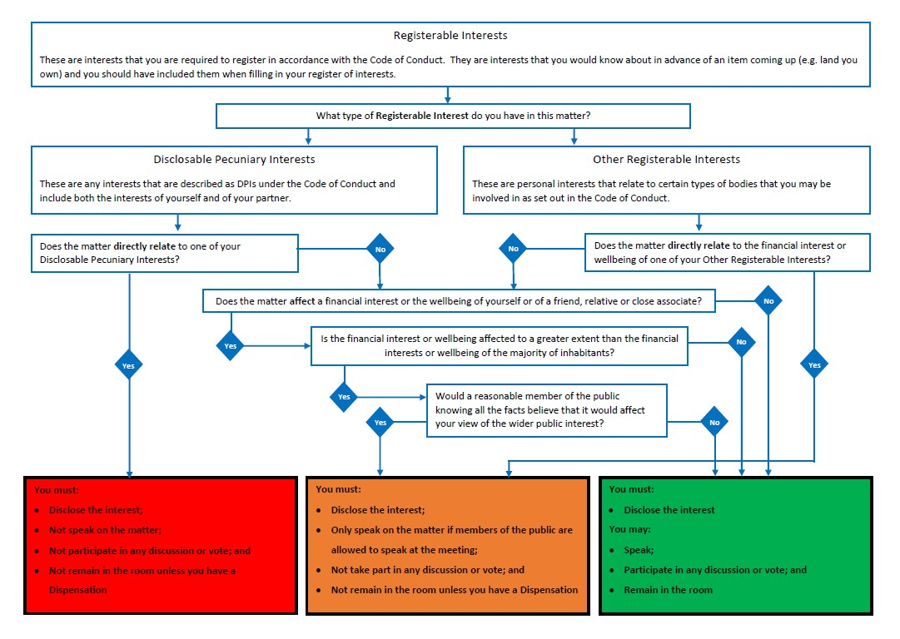

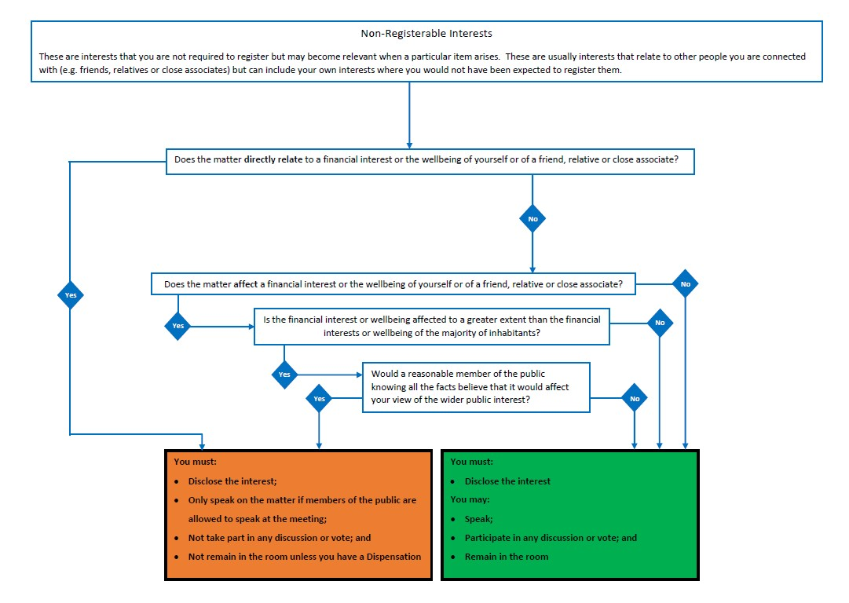

Appendix C

The Committee on Standards in Public Life

The LGA has undertaken this review whilst the Government continues to consider the recommendations made by the Committee on Standards in Public Life in their report on Local Government Ethical Standards. If the Government chooses to implement any of the recommendations, this could require a change to this Code.

The recommendations cover:

- Recommendations for changes to the Localism Act 2011 to clarify in law when the Code of Conduct applies
- The introduction of sanctions
- Appeals process through the Local Government Ombudsman
- Changes to the Relevant Authorities (Disclosable Pecuniary Interests) Regulations 2012
- Updates to the Local Government Transparency Code
- Changes to the role and responsibilities of the Independent Person
- That the criminal offences in the Localism Act 2011 relating to Disclosable Pecuniary Interests should be abolished

The Local Government Ethical Standards report also includes Best Practice recommendations. These are:

Best practice 1: Local authorities should include prohibitions on bullying and harassment in codes of conduct. These should include a definition of bullying and harassment, supplemented with a list of examples of the sort of behaviour covered by such a definition.

Best practice 2: Councils should include provisions in their code of conduct requiring members to comply with any formal standards investigation and prohibiting trivial or malicious allegations by members.

Best practice 3: Principal authorities should review their code of conduct each year and regularly seek, where possible, the views of the public, community organisations and neighbouring authorities.

Best practice 4: An authority’s code should be readily accessible to both members and the public, in a prominent position on a council’s website and available in council premises.

Best practice 5: Local authorities should update their gifts and hospitality register at least once per quarter, and publish it in an accessible format, such as CSV.

Best practice 6: Councils should publish a clear and straightforward public interest test against which allegations are filtered.

Best practice 7: Local authorities should have access to at least two Independent Persons.

Best practice 8: An Independent Person should be consulted as to whether to undertake a formal investigation on an allegation, and should be given the option to
review and comment on allegations which the responsible officer is minded to dismiss
as being without merit, vexatious, or trivial.

Best practice 9: Where a local authority makes a decision on an allegation of misconduct following a formal investigation, a decision notice should be published as soon as possible on its website, including a brief statement of facts, the provisions of the code engaged by the allegations, the view of the Independent Person, the reasoning of the decision-maker, and any sanction applied.

Best practice 10: A local authority should have straightforward and accessible guidance on its website on how to make a complaint under the code of conduct, the process for handling complaints, and estimated timescales for investigations and outcomes.

Best practice 11: Formal standards complaints about the conduct of a parish member towards a clerk should be made by the chair or by the parish council, rather than the clerk in all but exceptional circumstances.

Best practice 12: Monitoring Officers’ roles should include providing advice, support and management of investigations and adjudications on alleged breaches to parish councils within the remit of the principal authority. They should be provided with adequate training, corporate support and resources to undertake this work
.
Best practice 13: A local authority should have procedures in place to address any conflicts of interest when undertaking a standards investigation. Possible steps should include asking the Monitoring Officer from a different authority to undertake the investigation.

Best practice 14: Councils should report on separate bodies they have set up or which they own as part of their annual governance statement and give a full picture of their relationship with those bodies. Separate bodies created by local authorities should abide by the Nolan principle of openness and publish their board agendas and minutes and annual reports in an accessible place.

Best practice 15: Senior officers should meet regularly with political group leaders or group whips to discuss standards issues.

The LGA has committed to reviewing its Model Code on an annual basis to ensure it is still fit for purpose.

